

**Subject: Software Engineering**

**Subject code: IT632**

**Final Assignment - Deliverable Code : 04**

Date of submission: 02-05-2023

Due date of submission:02-05-2023

**Name: Dev Adnani**

**Topic: Zoom Video Conference Application**

System Architecture:

* The Zoom system architecture is based on a client-server model.
* The system comprises multiple servers located in different regions of the world.
* The client application is available on various platforms, including desktops, laptops, tablets, and smartphones.
* The system utilizes different protocols for different aspects of the communication process, such as audio, video, and data transfer.
* The system uses advanced encryption algorithms to secure data and communication.

System Design:

* The system is designed to be user-friendly and easy to use, with a simple and intuitive interface.
* The system allows users to schedule, host, and join meetings with ease.
* The system provides different options for users to join meetings, including through a web browser, a desktop application, or a mobile app.
* The system supports a wide range of features, including screen sharing, virtual backgrounds, and breakout rooms.
* The system has multiple layers of security to protect user privacy and data.

DFD Level 0

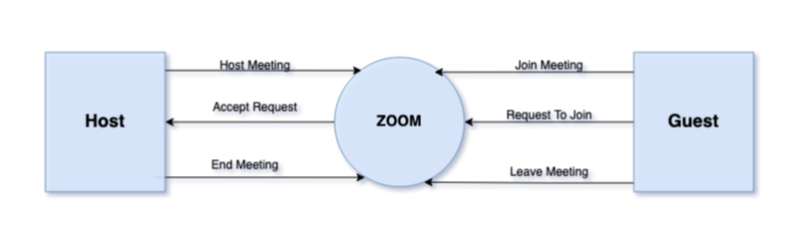

DFD Level 1

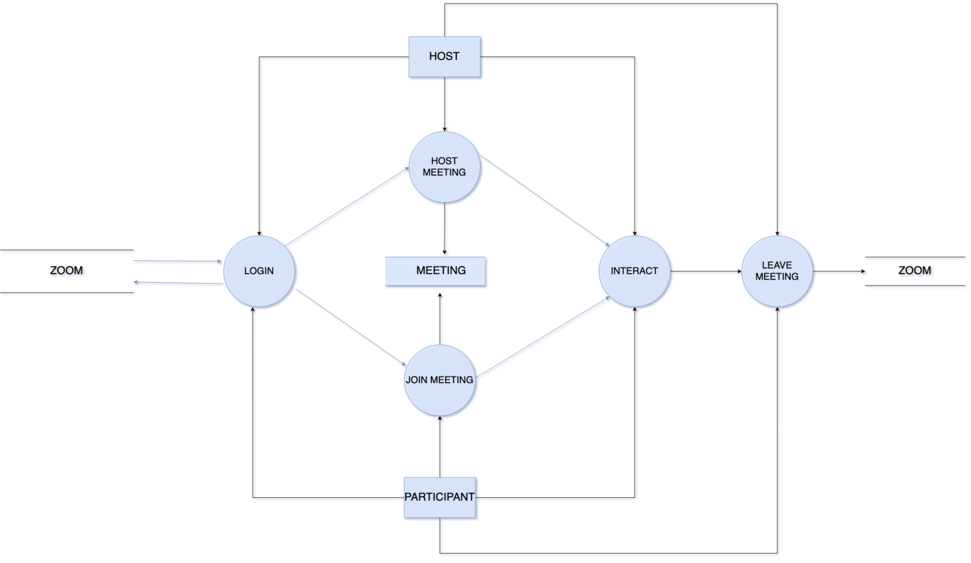

DFD Level 2

